Berufsfachschule Basel
Search results for "Englische Filme"

 | Author / Title | Place, Editor, Year | Medientyp | Call number / Availability
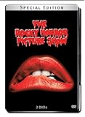 | Sharman, Tim  The Rocky Horror Picture Show | Los Angeles : Twentieth Century Fox Film Corporation, 2003 | DVD-Spielfilm | ROCK  available

