Berufsfachschule Basel
Search results for "Englische Bücher"

 | Author / Title | Place, Editor, Year | Medientyp | Call number / Availability
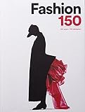 | Schiavi, Alessia  Fashion 150 : 150 years / 150 designers | London : Laurence King Publishing, 2016 | Sachbuch | 391  available

