Berufsfachschule Basel
Search results for "Beliebteste CDs"

 | Author / Title | Place, Editor, Year | Medientyp | Call number / Availability | Number of loans
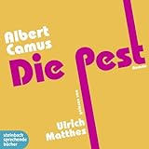 | Camus, Albert 1913-1960  Die Pest : Roman | O.O. : Steinbach sprechende Bücher, 2013 | CD | CAMU  available | 4

